**The Ark Documentation.**

**How to use the subject custom field uploader to UPDATE custom field data.**

Instruction Path a (with perfect data and no validation)

Log in and select our study.

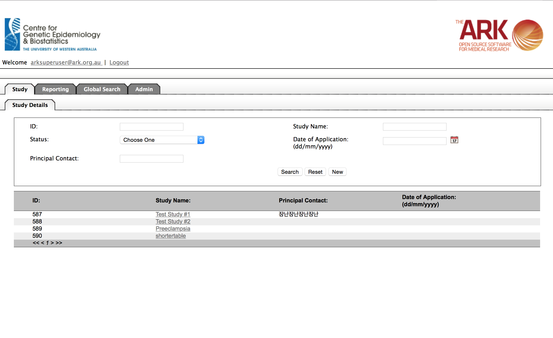

Once we have chosen our study we will see the following Modules and Functions Select Datasets

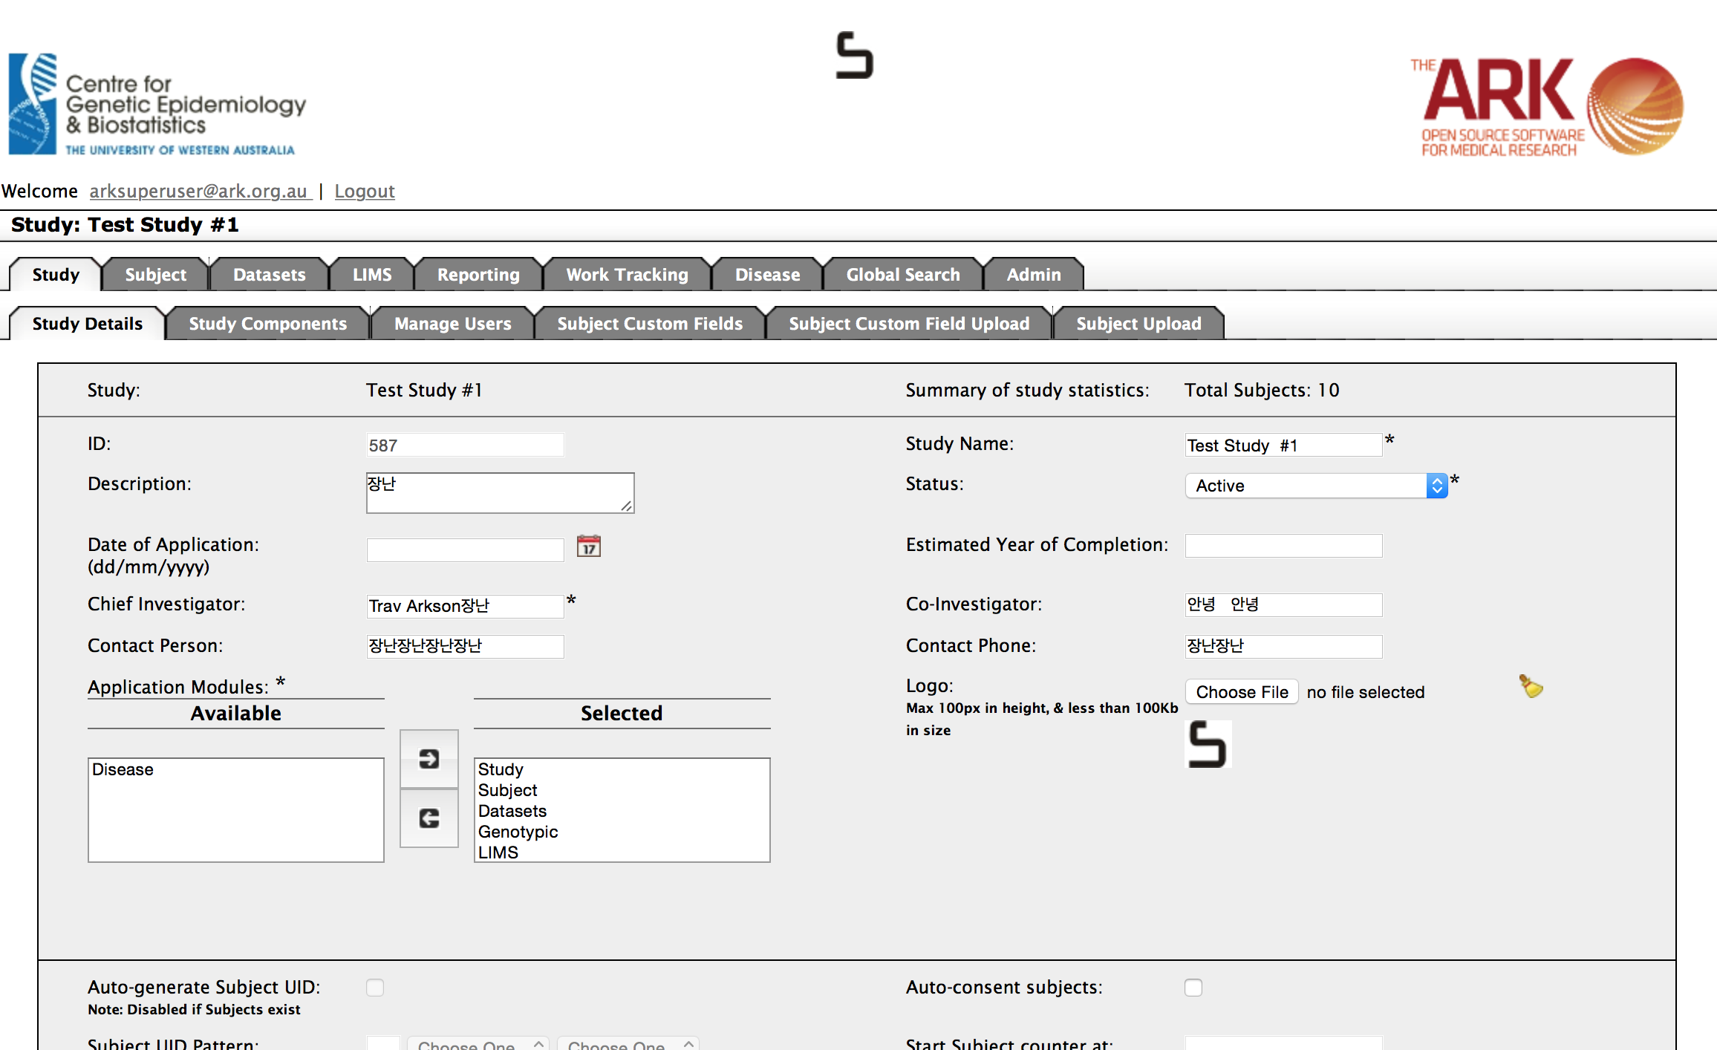

We will now see the following functions (tabs), and our available data dictionary (listing our fields). To look at the fields in detail click on one of the Field Names (eg; Drug)

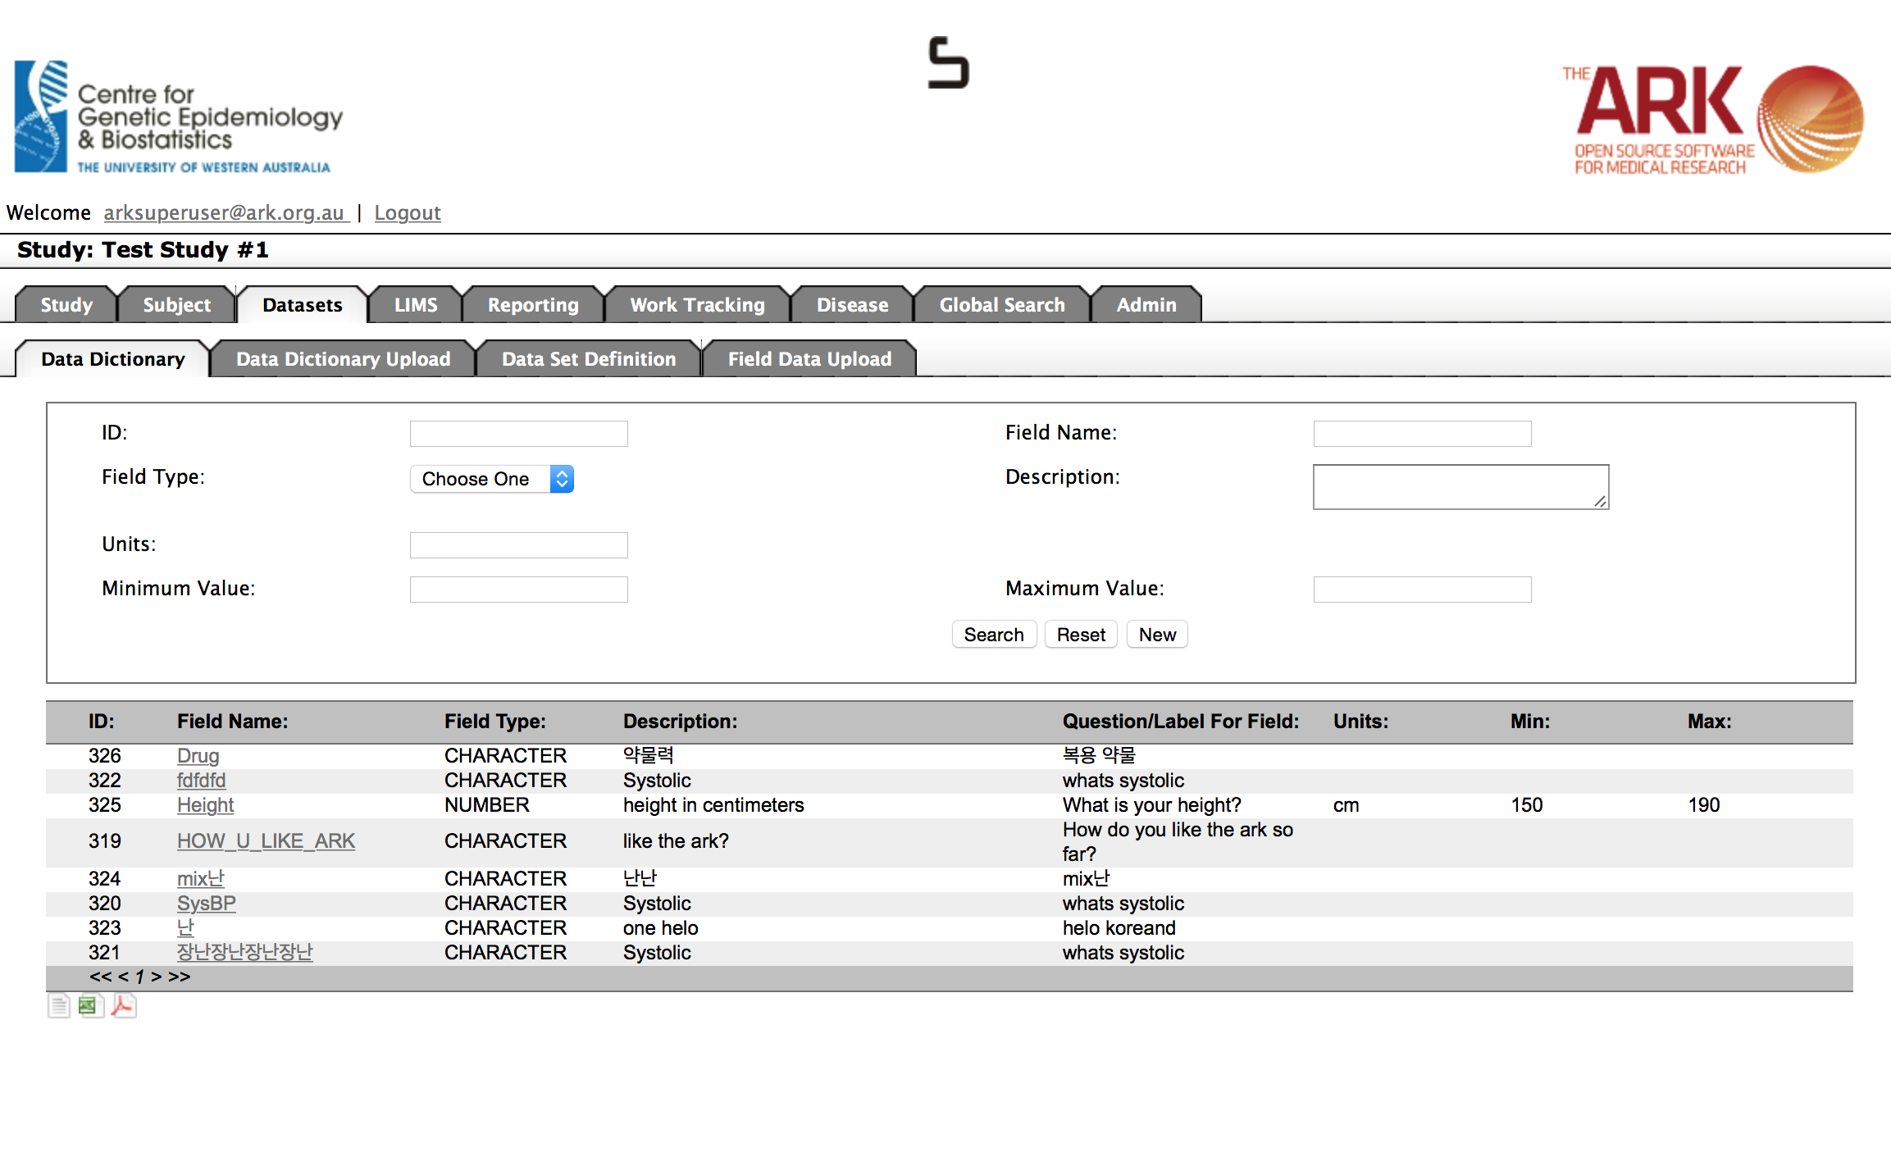

You now get to look at the Type of values accepted plus and validations such as minimum and maximums.

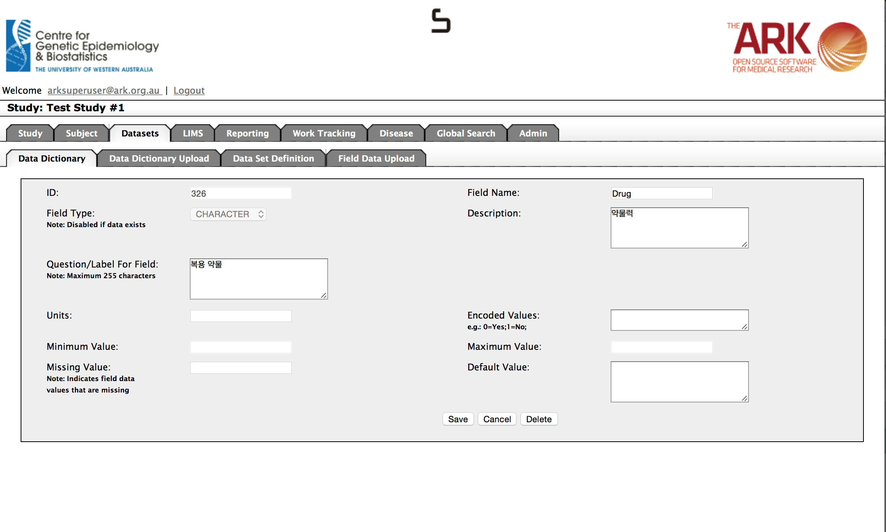

To look at, or to create and Dataset definitions (you could also view a dataset definition as a questionnaire or grouping of relevant (longitudinal) questions)

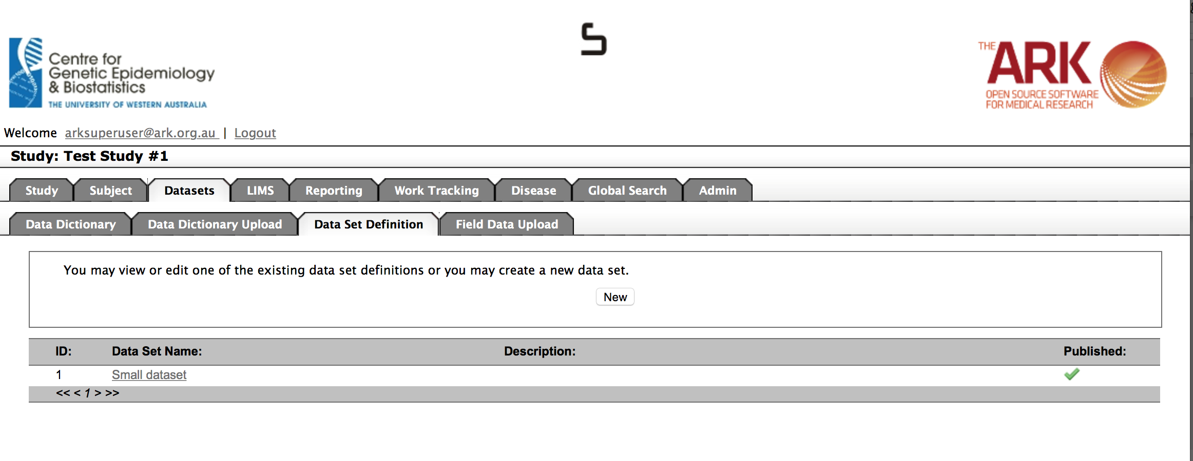

To look at your Dataset Definition, click on the Data Set Name.

Now we are looking at the dataset, where we can add or remove fields IF there is not existing datasets using this dataset definition. It also helps us know what data to put in our dataset upload.

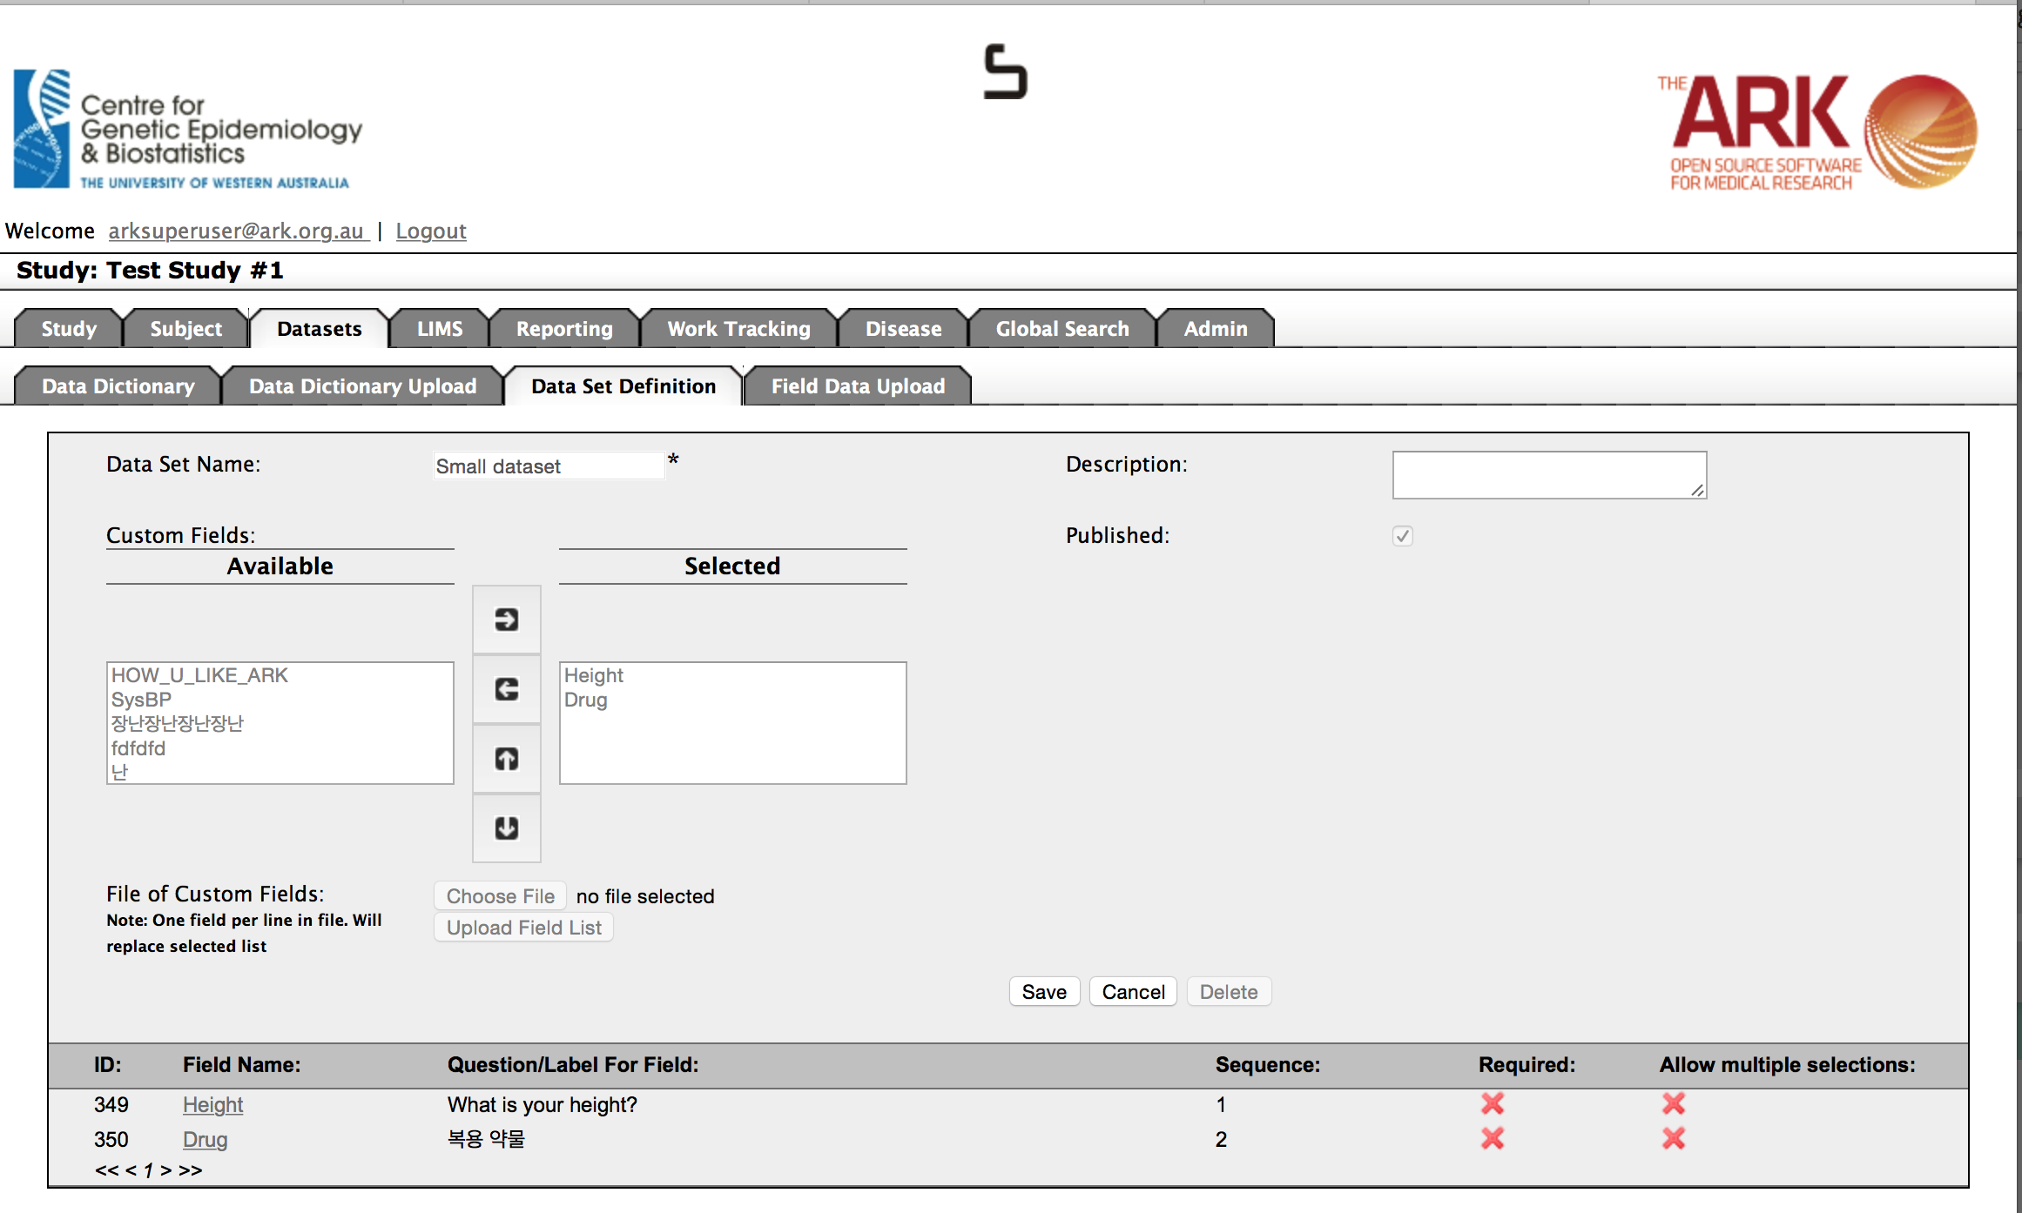

We now understand what data we can upload for this dataset. Click on Field Data Upload.

The following page will appear. You will see the following sections from top to bottom;

1. The files upload section. This is where you can begin the steps to upload subjects.
2. The Labels and Template download section. This will be described further below.
3. The Result list section. This section lists all previous uploads (if any…there are none yet in this example, but will be after we finish an upload).

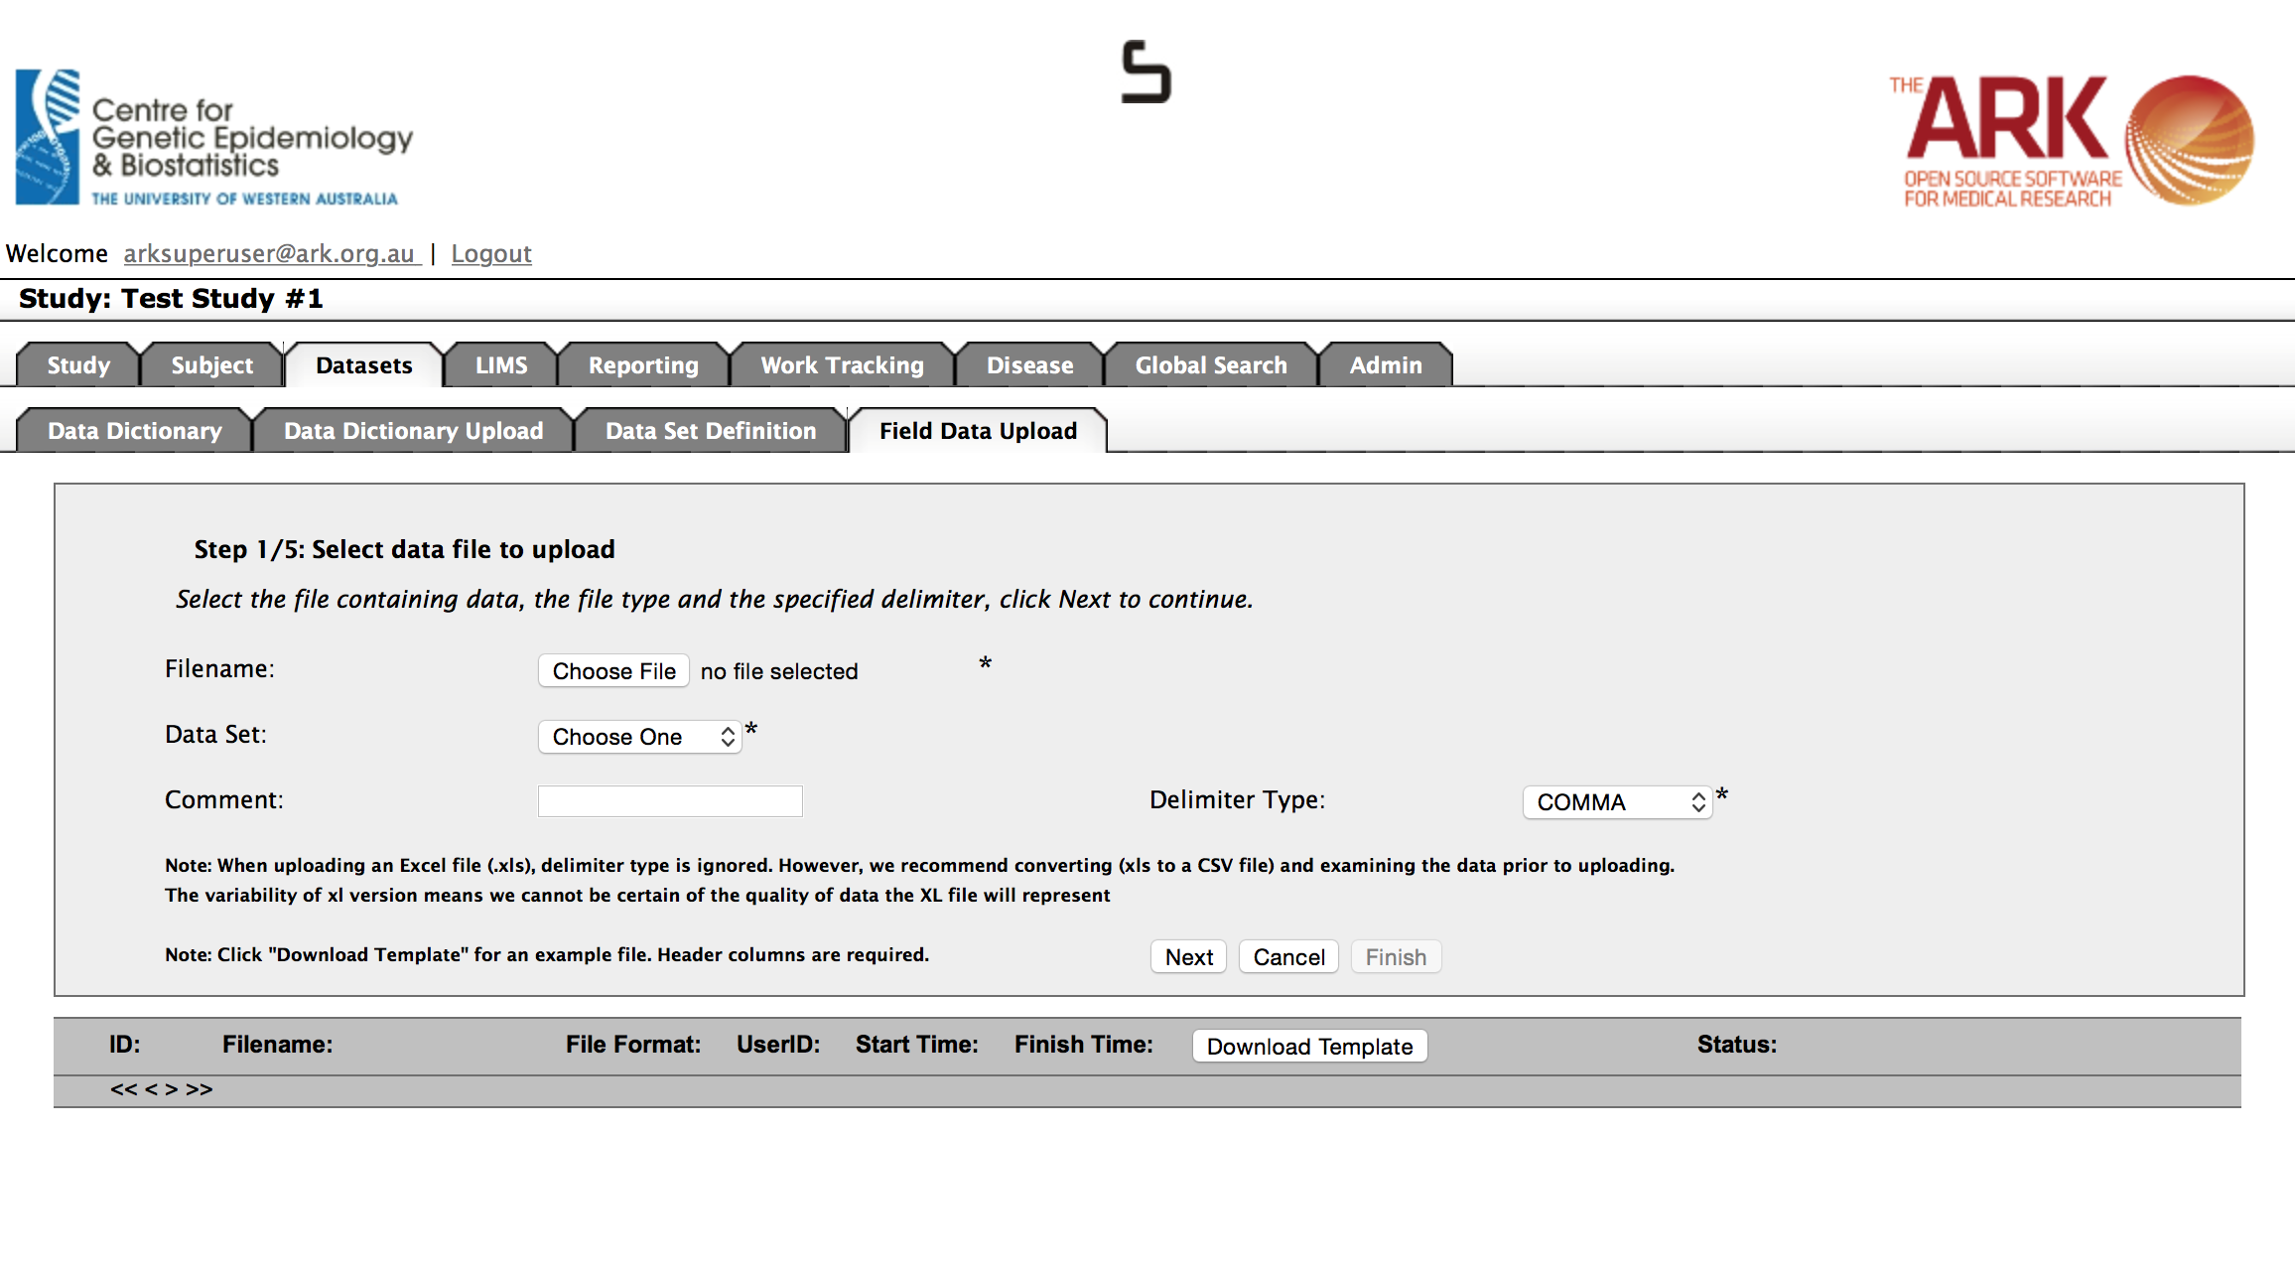

🡨1

🡨2

🡨3

The next step is to upload your data. You have two choices for your starting point;

1. You can select Download Template if you are unsure about the format. The template lists which fields are mandatory, what type/format of data is expected and valid values for fields that are limited in that way (see below).



As you can see, this template is more of a guide than a generated file. You have to fill out the field names in the headers eg;

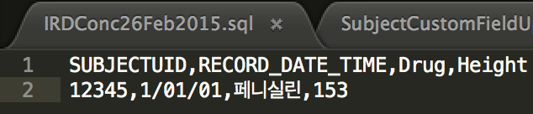

1. Alternatively, you can access an example from the usefulTools/csvTemplatesForUploaders directory of our code repository. If you have not been given a local version of our repository you can access it from

<https://code.google.com/p/ark-informatics/source/browse/#svn%2FARK%2Ftrunk%2FusefulTools%2FcsvDataForUploaders>

For the example below I utilized (updated) the PhenoUploadUTF8KoreaEnglishMixl.csv template file. You could also use the file you originally used to insert the data, but I strongly advise that you ONLY use the data you intend to update in order to avoid losing the current state of your data.

**Important Note For Internationisation (i18n):**

This guide is created assuming you have taken all the steps necessary to ensure your Ark instance is completely setup for UTF-8 (contact [ark-gohad@uwa.edu.au](mailto:ark-gohad@uwa.edu.au) if you need help with this).

**Always save your data as UTF-8.** Many text editors such as Sublime Edit will do this to your CSV files. But the biggest thing is to make sure previous applications such as Excel DO NOT destroy your previous work. If possible always try to simply start off your document with UTF-8 as your first encoding as this is an international standard to ensure that you can have any international character set.

If you must convert character sets, here is an example of how I converted a UTF-16 csv containing Korean and English to UTF-8 for use in The Ark.

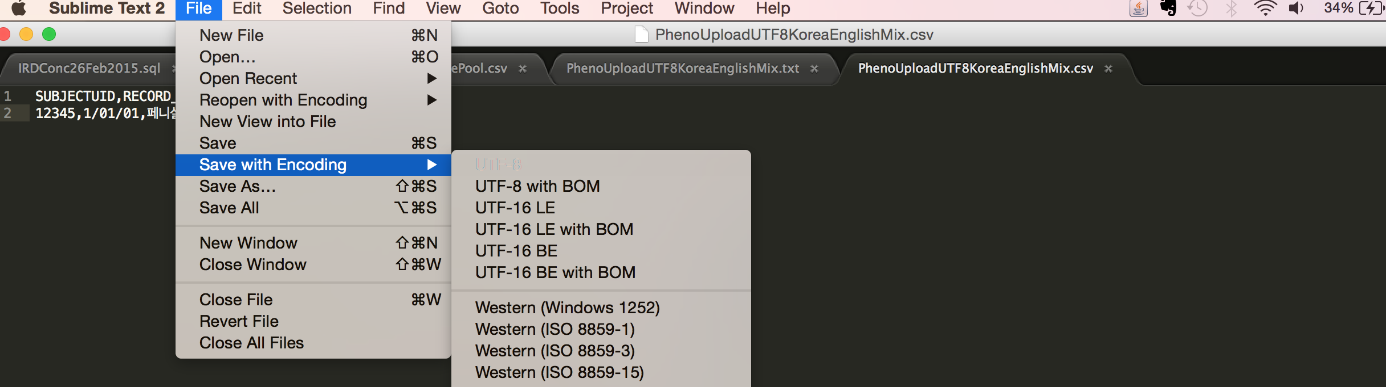

Once you have taken the steps listed above to ensure you have the fields you wish to upload, save the file, then you simply;

1. Select the filename of that file in the “The files upload section“.
2. Leave the delimiter type as COMMA, if appropriate.
3. Add a comment describing this dataset you are uploading. This can be important for longitudinal data, as it helps to clearly define what your are looking at later if your have many datasets/questionaires over time and want to quickly recognize one.
4. Click the Next button once.



This will take you to the step 2. This page will let you know if the file structure is correct for the upload type. If an error occurs you can click cancel and correct the mistake.

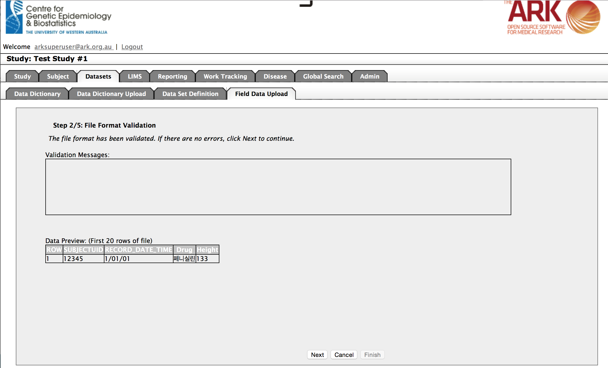

But on this occasion, we can see no validation messages at step 2, so I can assume everything is ok and click next at the bottom of the page (the next step will validate all of your **data** Vs what is expected, so can take some time on very large files. Please be patient and don’t click back, as it is busy doing work and will let you know when it is complete).

**SIDENOTE : Ensuring Excel doesn’t add extra commas and lines;**

If you passed validation on Step one of the previous page disregard this information. If you are having an error message, this can often help you out.

Step 1: Select all (or at least those that may have have once had data) columns after our last column of actual data

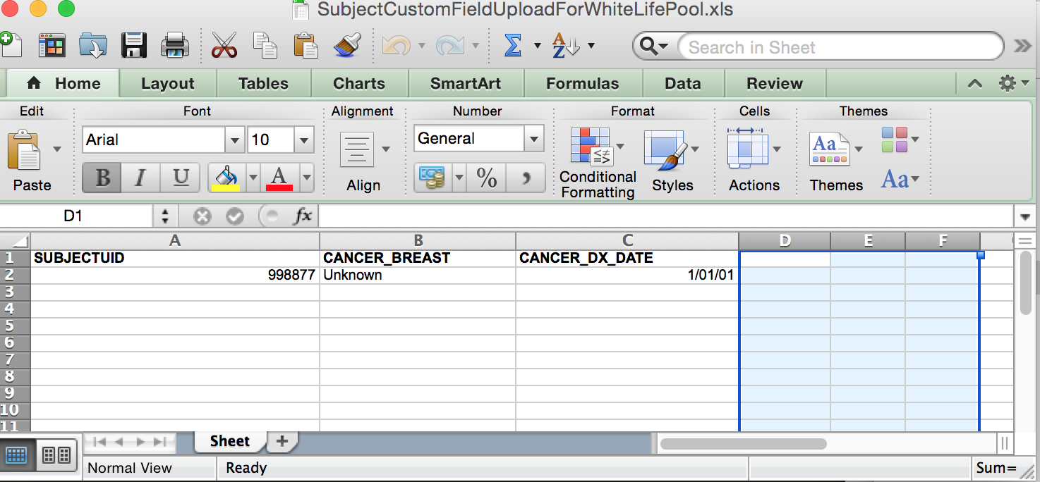

Step 2: Delete selected columns

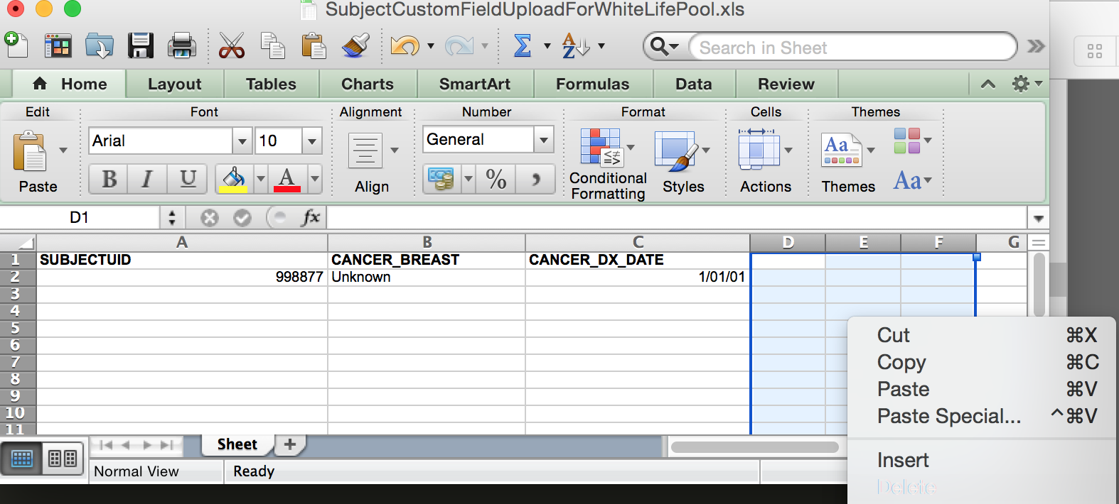

Step 3 & 4; Repeat the process by selecting and deleting all rows after our last row of data.

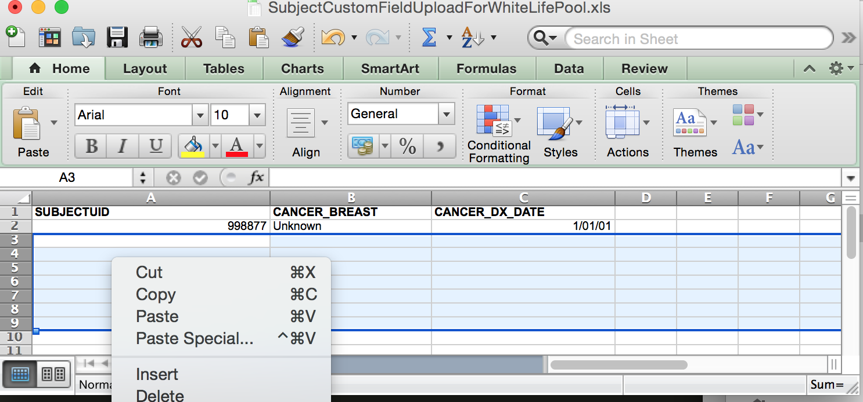

Step 5: Now save as CSV file.

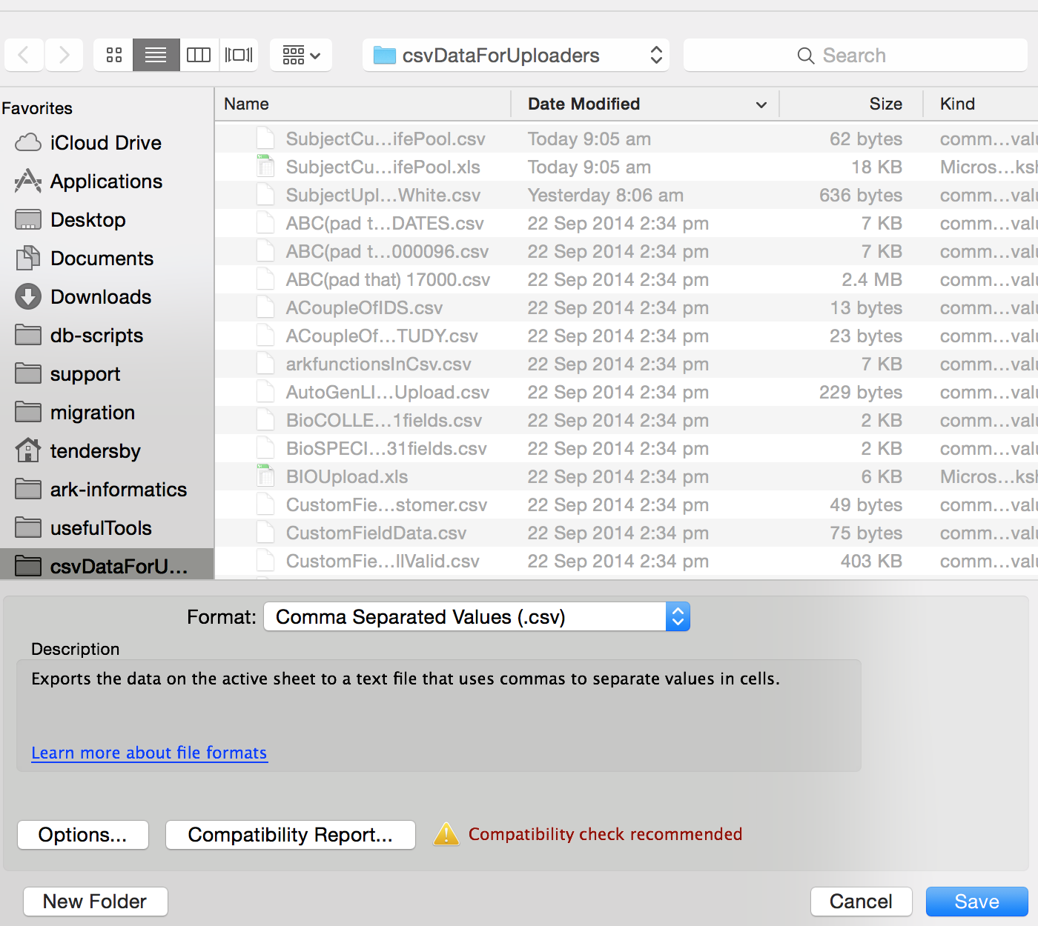

Step 6: Check your data in a plane text editor (eg; Notepad, sublime edit, vi, vim, TextEdit). It should now have no extra commas and no extra lines.

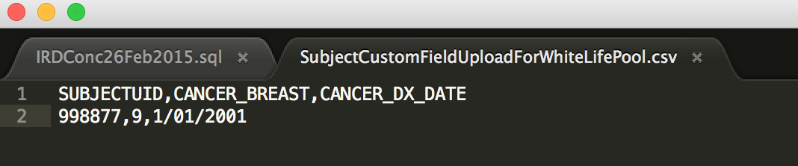

So now our upload data is as expected, we can try again.

We click cancel at the bottom of The Ark page and start the upload again.

We are now at step 3. This step shows if anything went wrong in step 2. The validation messages say that we have a value out of the expected range (ie; this dataset has a rule that height must be greater than 150, yet our listed height is 133). So I have to fix the data and try again.

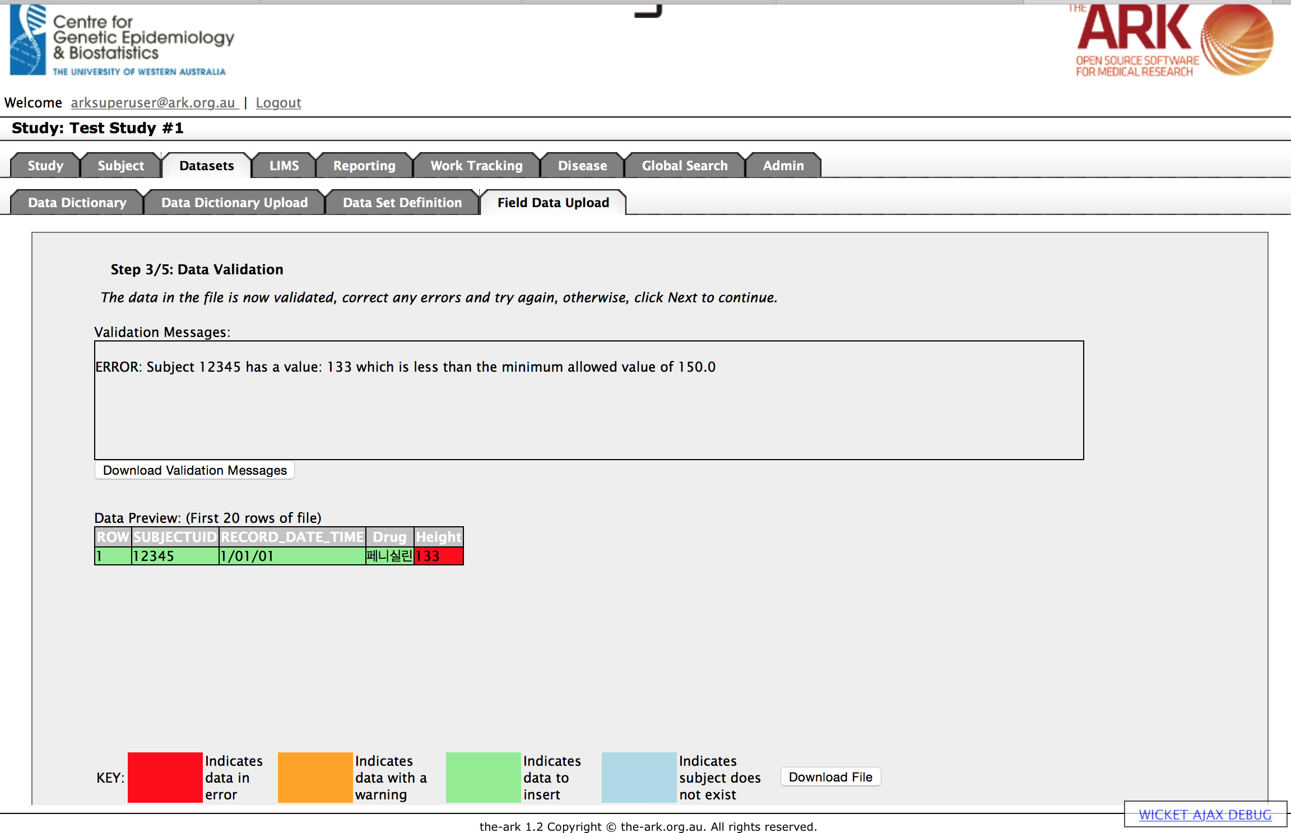

Click cancel and go and fix your data, and then repeat steps one and two again.

If we have corrected all of our data error we will now see an empty box for the validation messages.

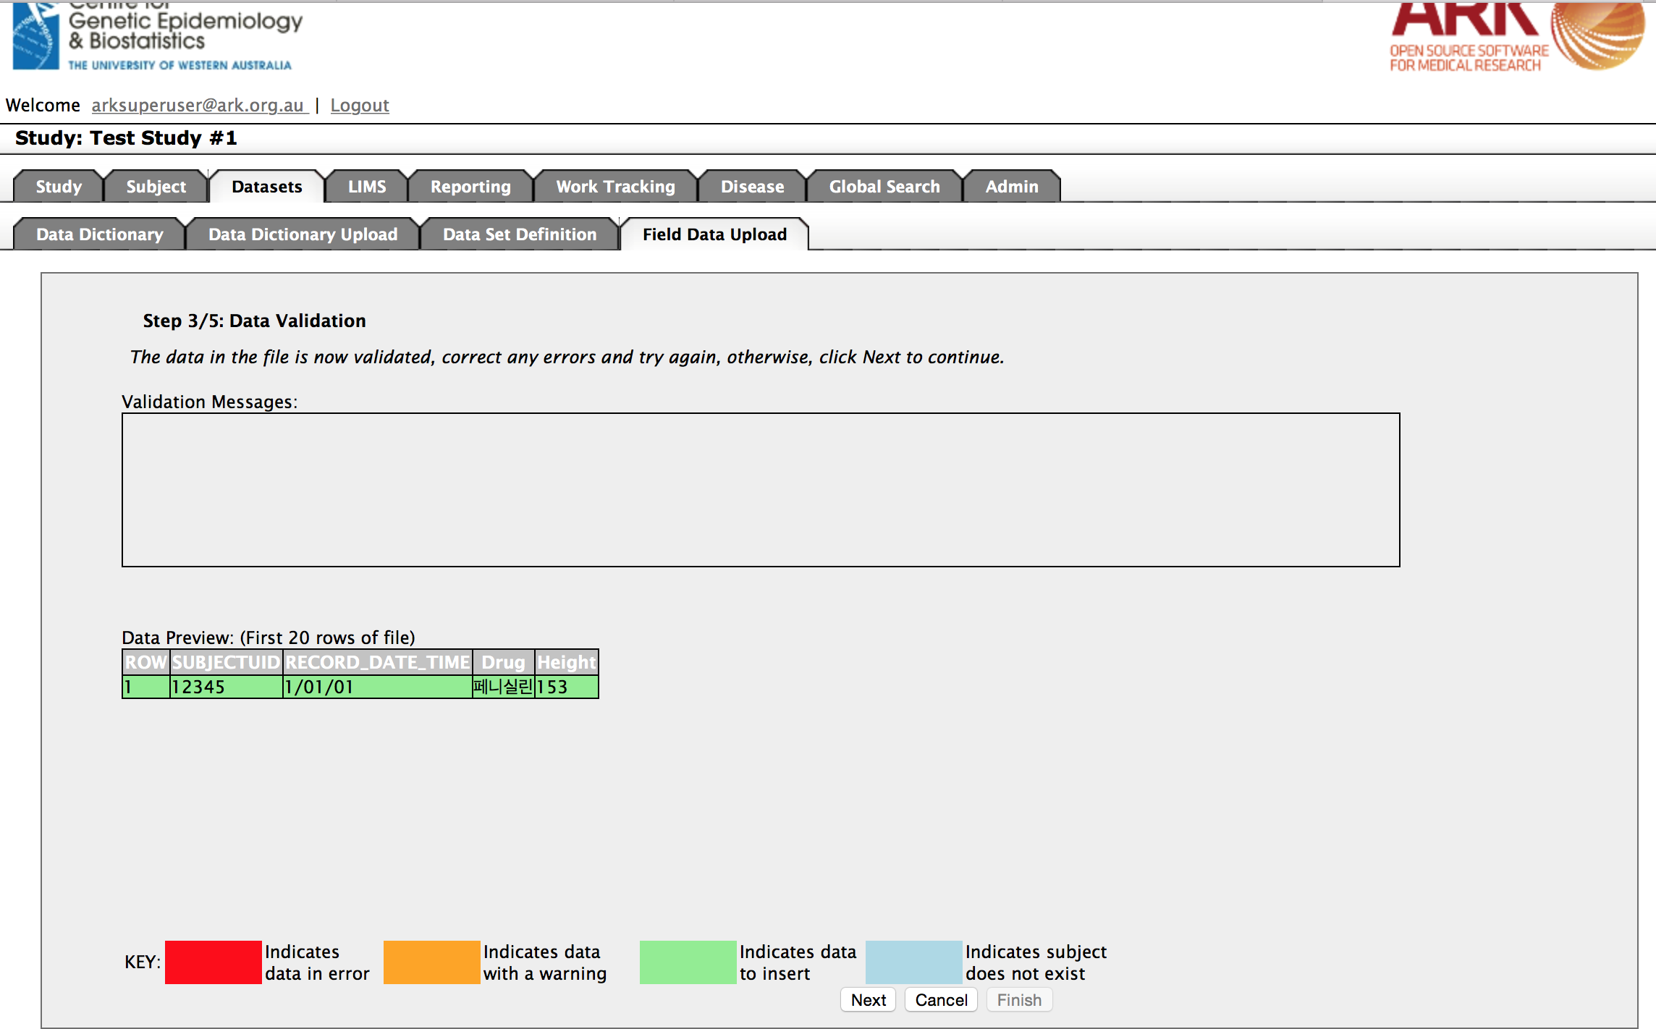

If things look good, you can therefore click next if you are happy with the data you see.

(SIDE NOTE; It is worth noting the dataset uploader DOES NOT UPDATE data. Dataset data is LONGITUDINAL, and we assume that each time you upload data it is intended to be a new longitudinal set)

You have now confirmed you are accepting the data, click next one more time and a BATCH process will begin.

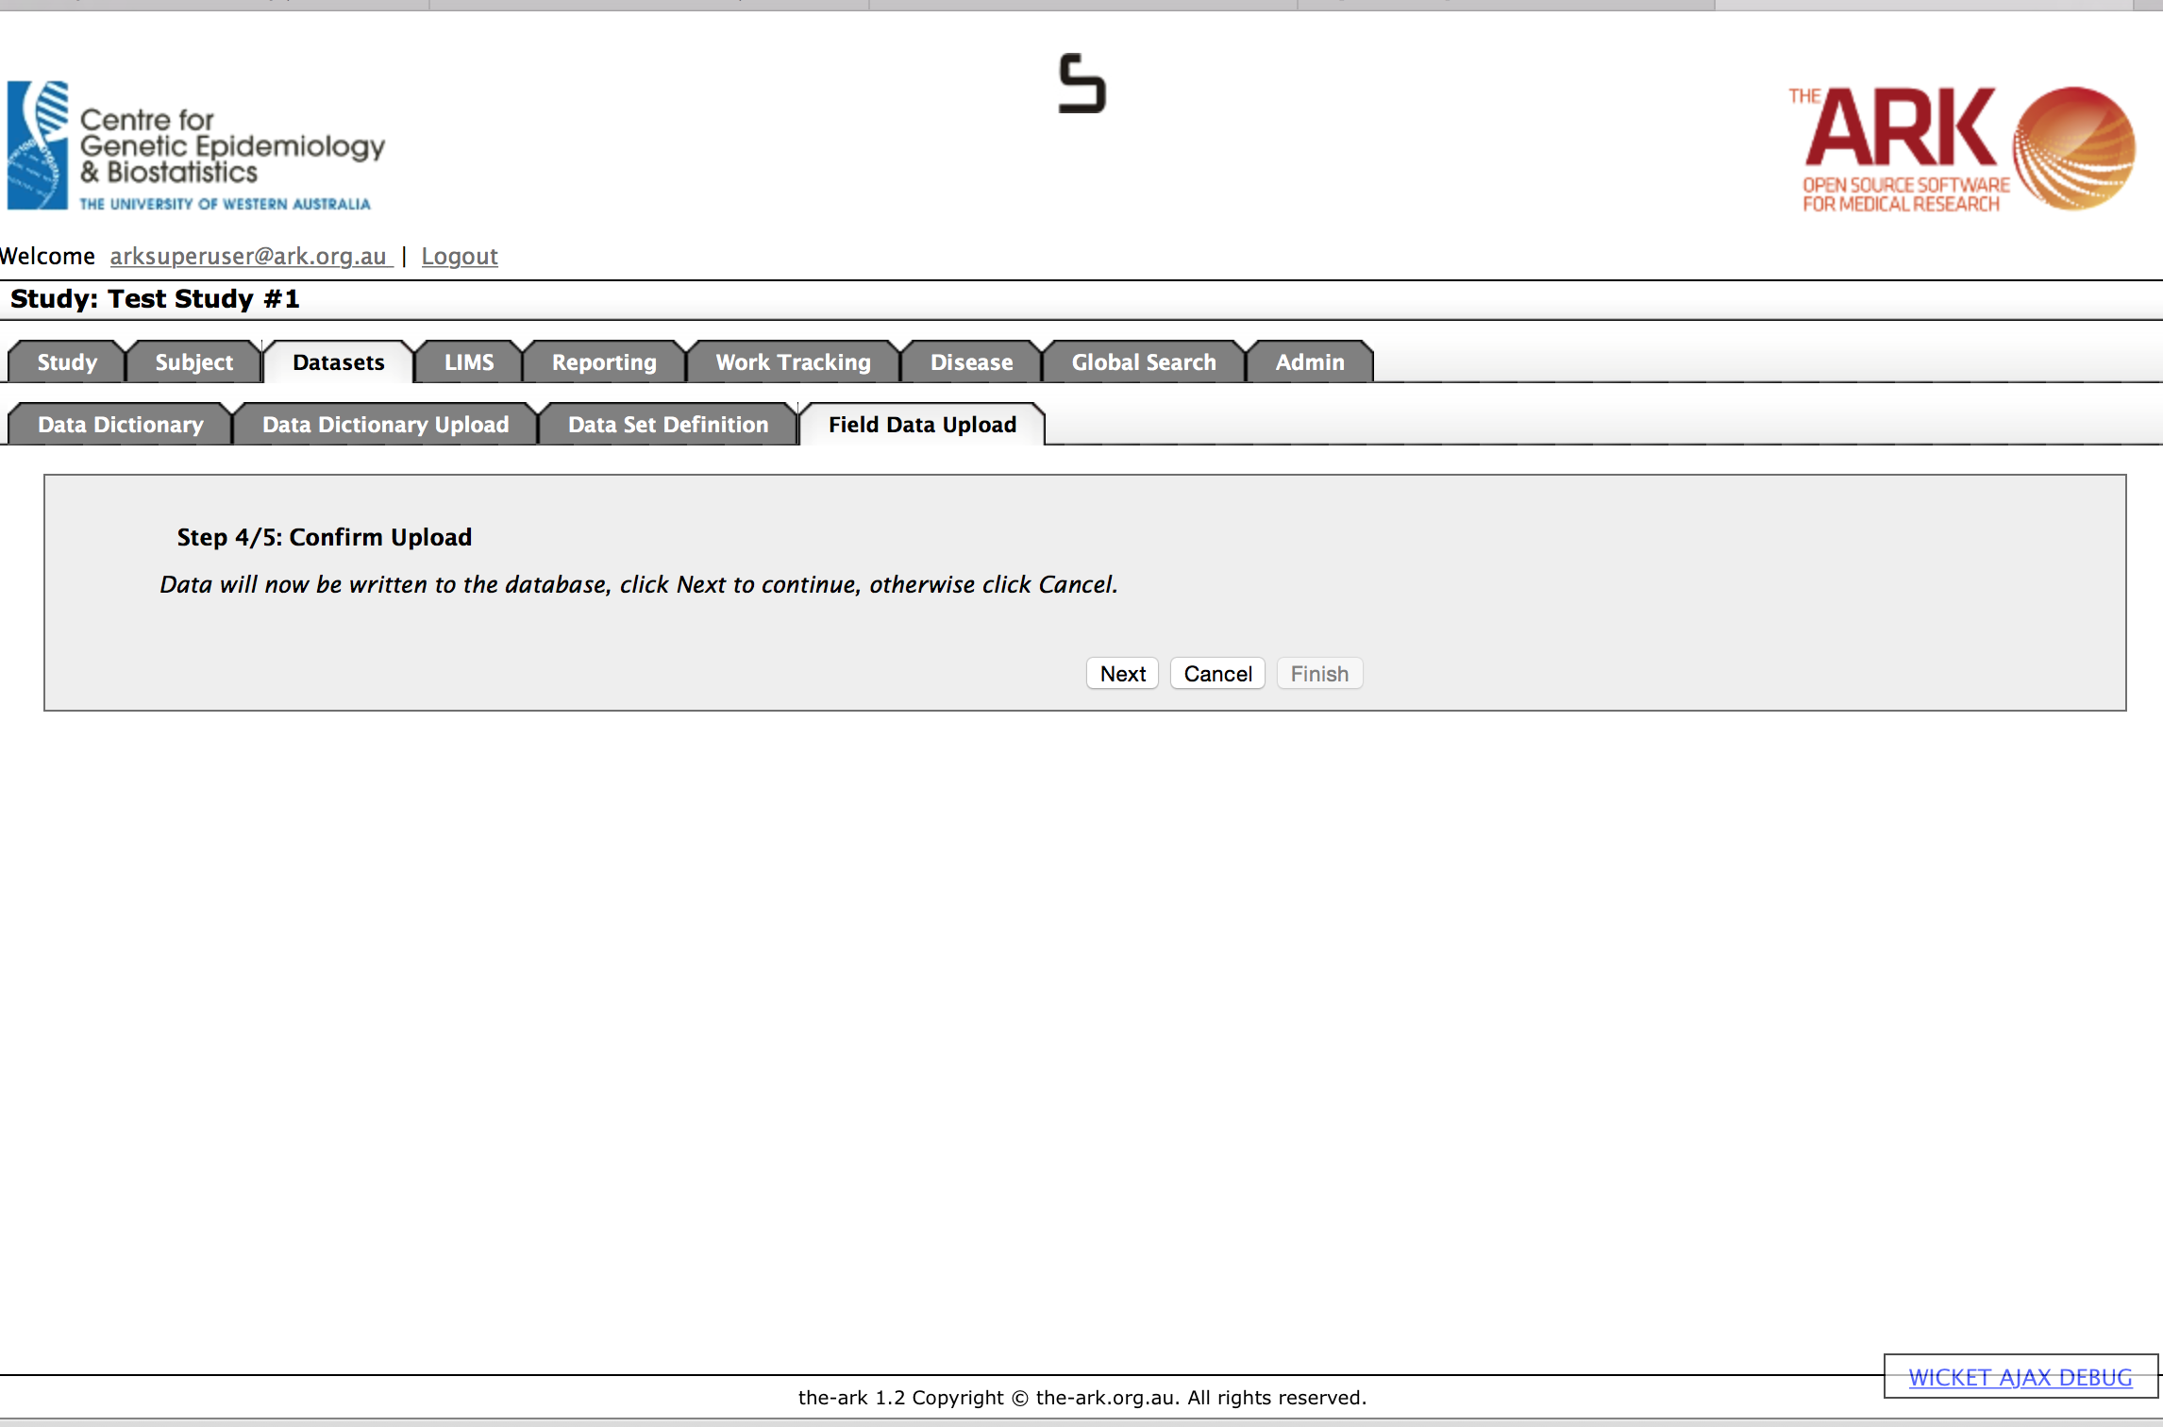

You now have completed the final step and can click finish whenever you want…

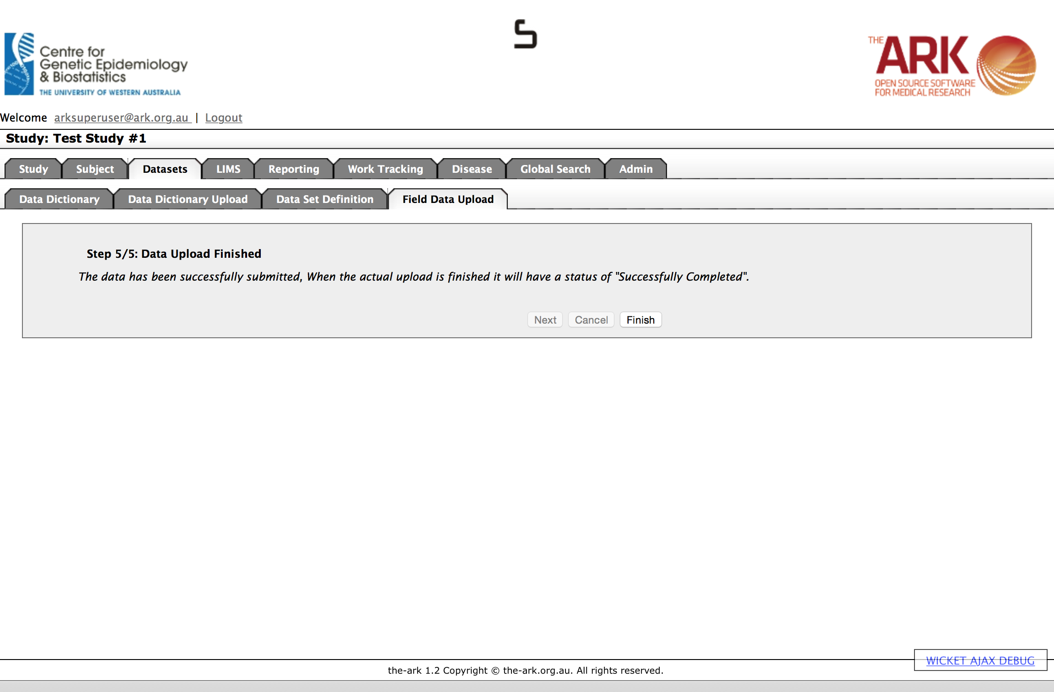

BUT you must know that the data has been submitted BUT it has not been completed until the result list page says that your upload is in a “Successfully Completed” status.

This is what a successful upload will look like on the result list section. You can also see what you two previous unsuccessful attempts looked like (the first time we failed validation of the file (headers or file type/format), the second time we failed validation of the data.

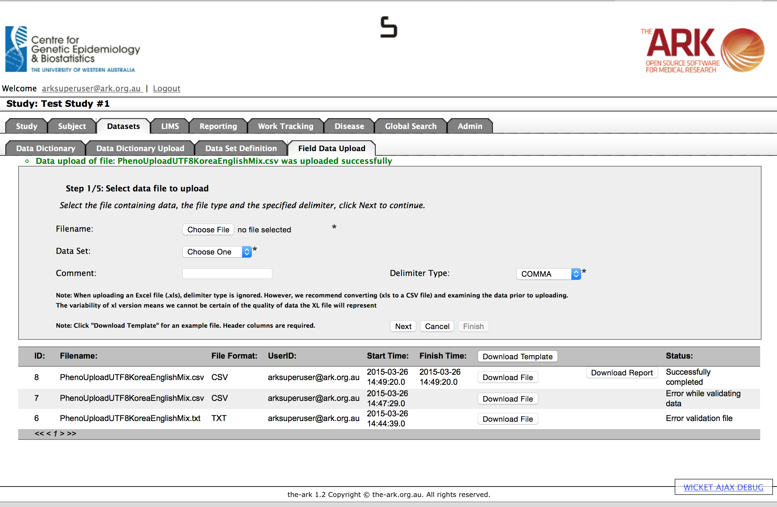

As you can see, in the results list for our successful upload, we have the options of Download File (this will down the original file you used) or Download Report which will give you a summary of what was uploaded, and any assumptions (or less serious errors) that were made upon successful rows. See an example below;

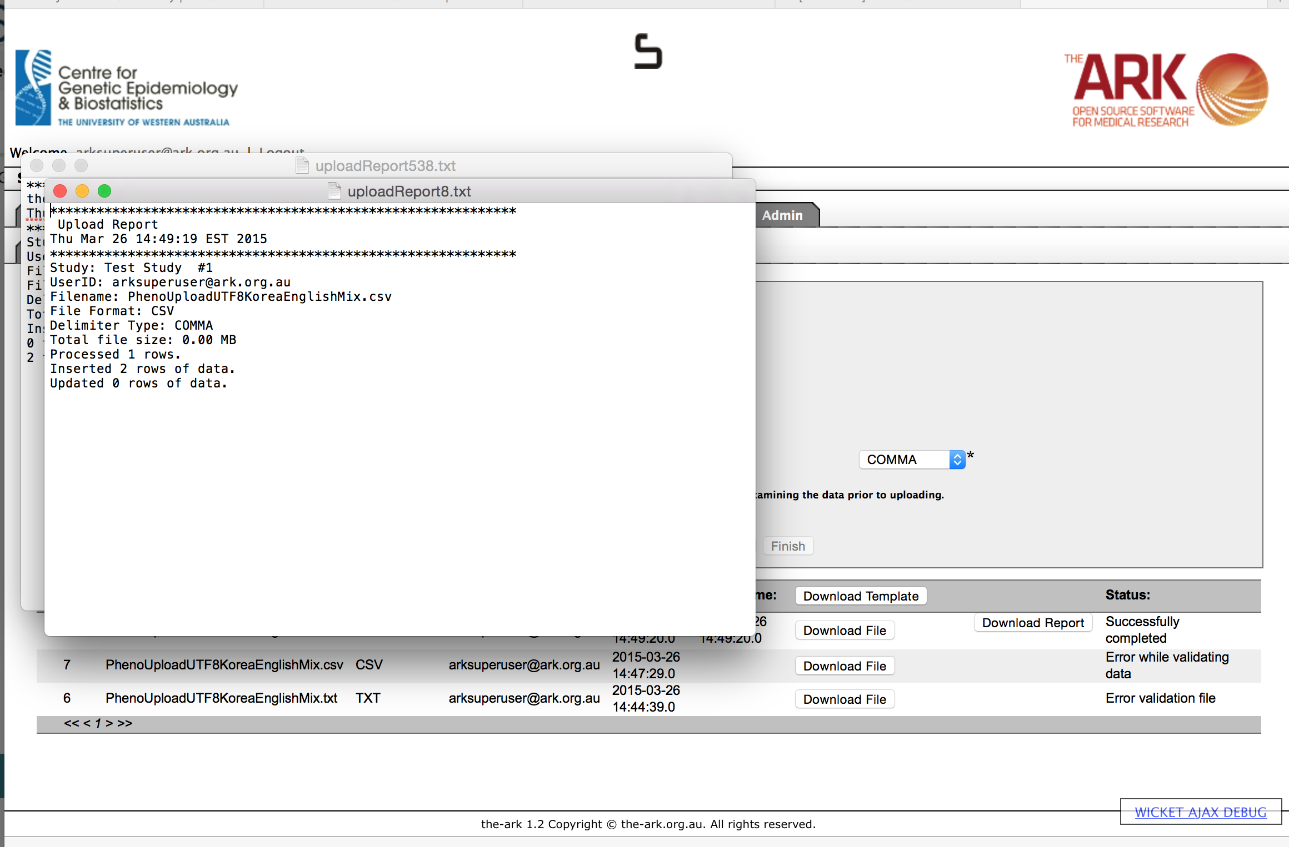

As always, we recommend you test what you just did to ensure the results were as you expected.

To do this, we click on the Subject Module Tab near the top of the page.

We can use a search term to find out subjects we wish to test

Click on his SubjectUID to test put this subject in Context.

Your next step is to click “Clinical Data” tab to see if the data was uploaded as expected. Hopefully all the data you expected is there. As we can see, our new data set we just added is there (I labelled it Trying English and Korean utf8 so I could easily recognize it later).

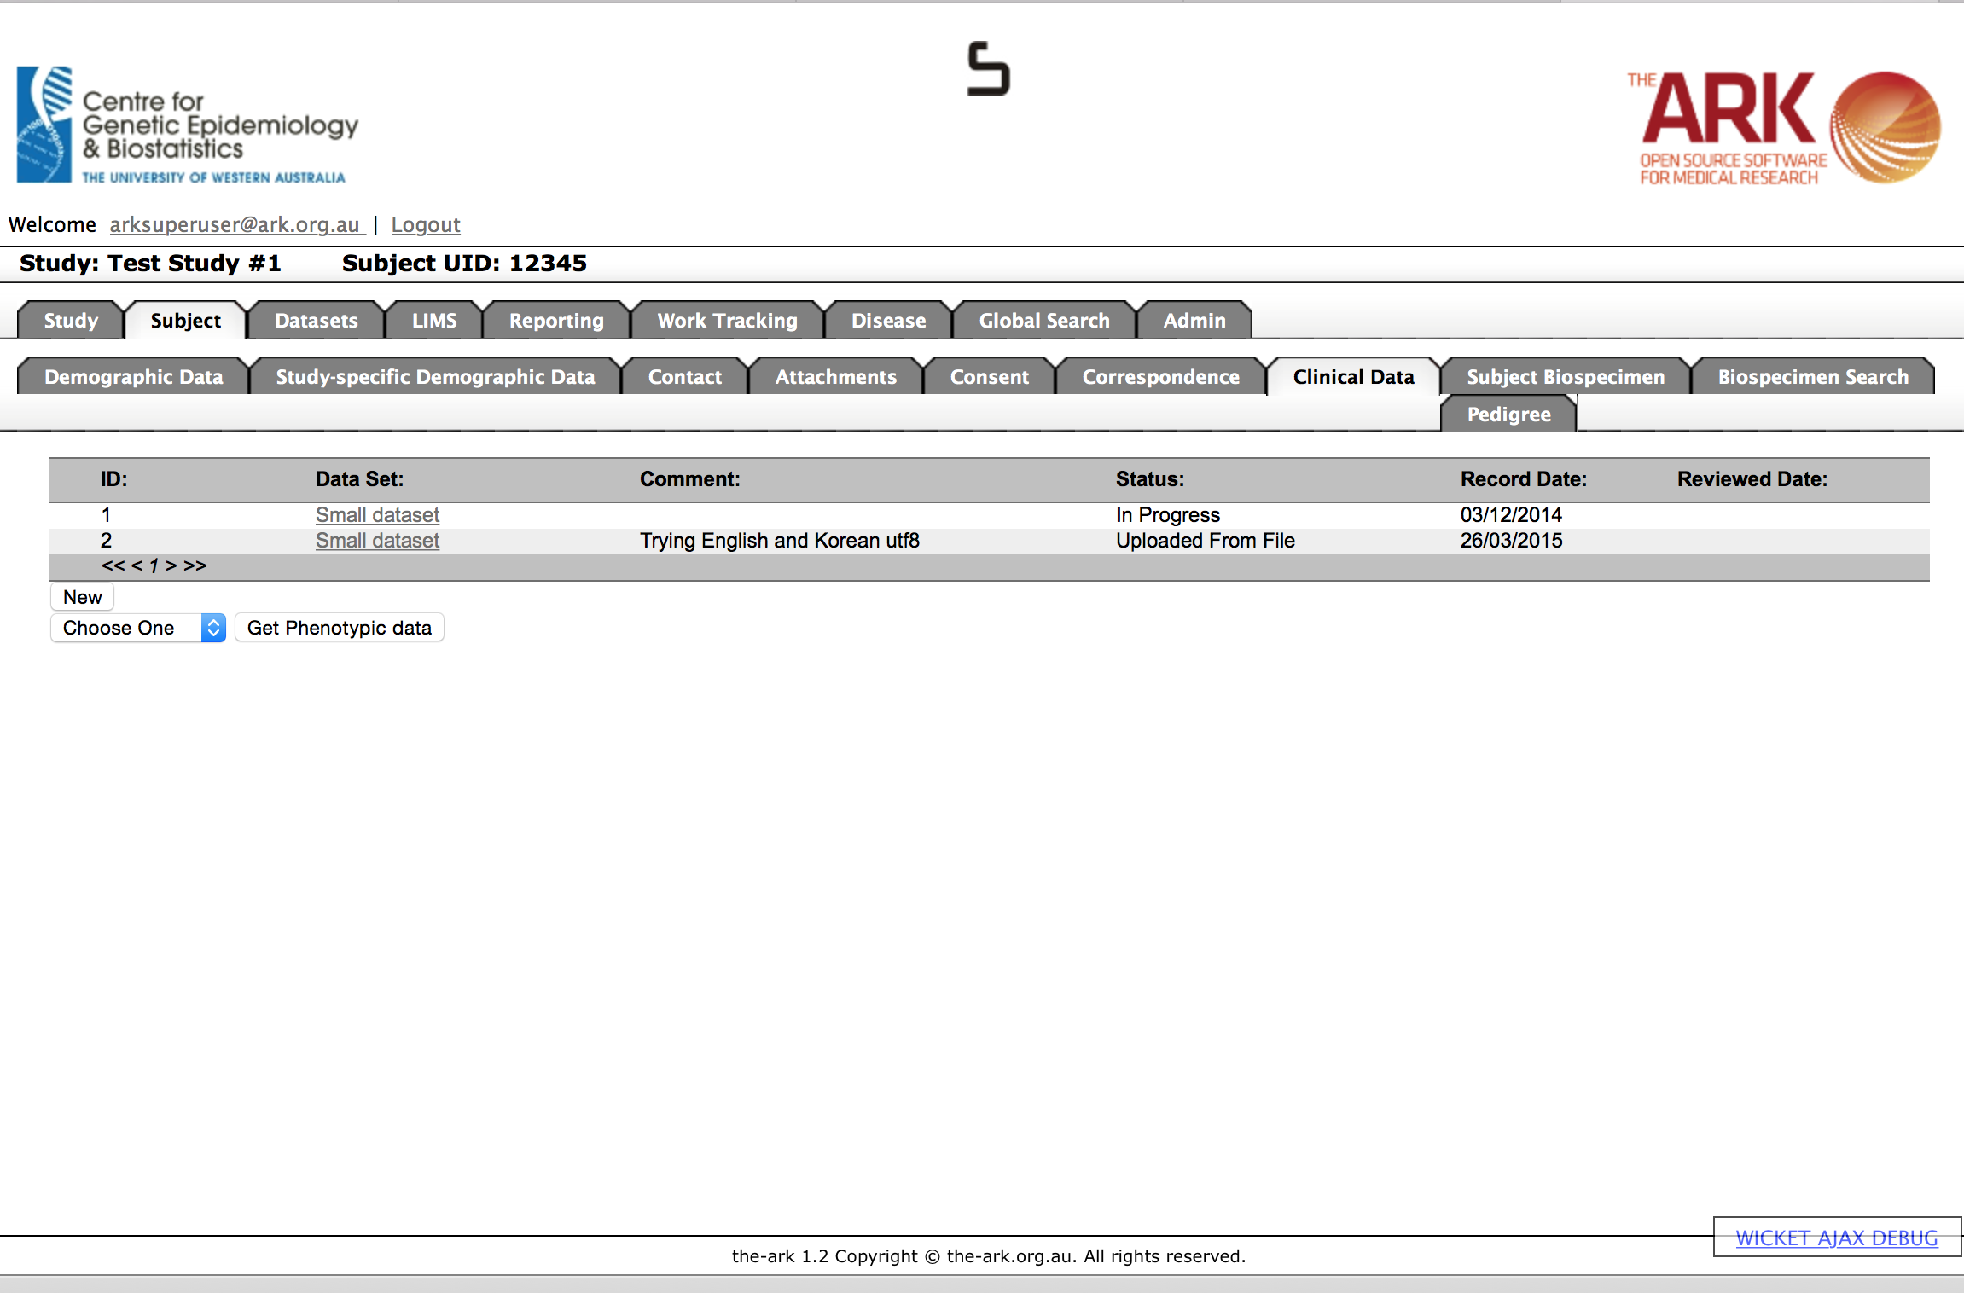

Click on the Dataset that we wish too look at.

We can see that our data has been updated correctly. It has a mixture of many international characters that are available as a part of the Universal UTF-8 charset (which enables many languages such as English, Korean and many more).

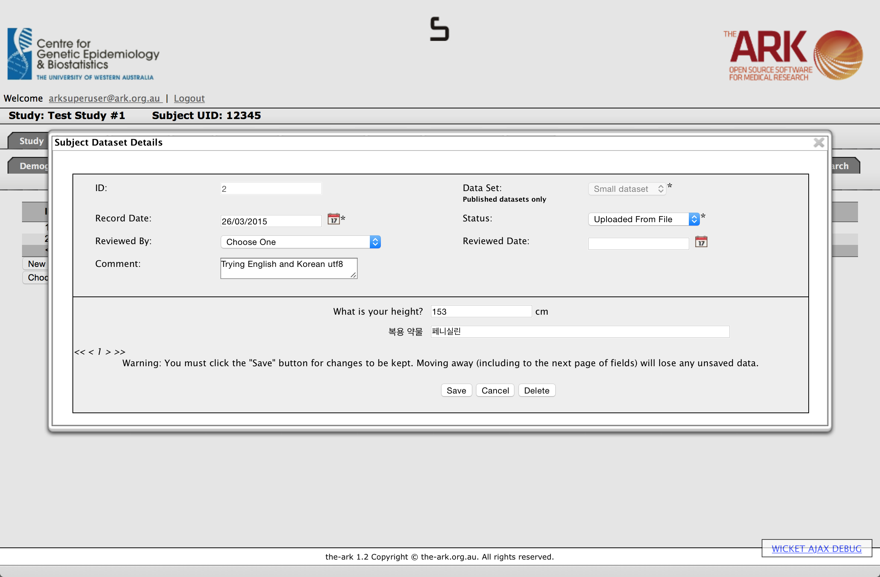

We also intend to put out a general guide to i18n and how to make sure your character encryption is created and always kept in UTF-8 to ensure it can work anywhere in the future.